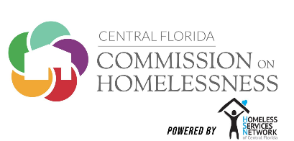

Utility Assistance Payment Agreement
For Supportive Housing Participants

Dear Program Participant,
This letter is to inform you that you are eligible to receive Utility Assistance through the Rapid Rehousing Program.
What is Utility Assistance?
Utility Assistance is a payment we will make each month to help you pay your utility bills. Based on your current income and housing costs, the program will pay a portion of your basic monthly utilities. Utilities include things like water, electric and gas.

How much Utility Assistance will I get?
Your expected Utility Assistance payment will be $_______________ per month. This amount will change if your income or rent amount changes.

How does Utility Assistance work?
We will make a payment every month on your behalf. In most cases, we will pay the utility company (OUC or Duke Energy) directly.

Will Utility Assistance cover the cost of my entire utility bill each month?
It depends. The more electricity and water you use, the higher your utility bill will be. If your utility bill is more than the Utility Assistance amount, you will be responsible for paying, by the due date, the balance owed to the utility company.

Example 1 - Your utility bills are HIGHER
than your Utility Assistance amount:
If your Utility Assistance = $120

and your total utility bills = $150
Then you are responsible to pay $30

Example 2 - Your utility bills are LOWER

than your Utility Assistance amount:
If your Utility Assistance = $120

and your total utility bills = $100
Then you receive a credit of $20
(Which will lower your bill next month)

By checking, the boxes and signing below you are agreeing to the following:
- To give Homeless Services Network permission to make direct payments to the utility company* listed below on your behalf.
- To be responsible for paying the difference directly to the utility company, if the monthly bill is higher than the allowance.
- To be responsible for reviewing the utility bill with your Case Manager each month, to understand what portion you are responsible for paying, if any.

Account Details: Utility Company Name:
Utility Account Number:
Participant Name:
Participant Signature: Date: ___
Case Manager Name:
Case Manager Signature: Date:

